IBM AIX (Advanced Interactive eXecutive) is a series of **proprietary Unix-based operating systems** developed and sold by IBM for several of its computer platforms, particularly their **IBM Power Systems servers**.

Here's a breakdown of key points about AIX:

* **Unix Heritage:** Built on the foundation of Unix System V, AIX offers a familiar and powerful operating system environment for experienced Unix users.
* **Enterprise Focus:** AIX is known for its reliability, security, and scalability, making it a popular choice for running critical business applications in large organizations.
* **Power Systems Integration:** AIX is tightly integrated with IBM Power Systems hardware, which can provide advantages in performance and optimization for certain workloads.

While not as widely used as Linux, AIX remains a solid option for businesses that require a stable and secure operating system for their mission-critical tasks on IBM Power Systems servers.

IBM Power Systems is a family of **server computers** produced by IBM that are designed for running critical business applications. They are known for their **reliability, security, and performance**. Here's a deeper dive into what IBM Power Systems are:

* **Processors:** Powered by IBM's own line of **POWER processors**, these servers are optimized for handling demanding workloads efficiently.
* **Operating Systems:** They can run various operating systems, including:
  + **AIX** (mentioned previously): A reliable and secure Unix-based OS for enterprise environments.
  + **IBM i** (formerly known as iSeries): An operating system specifically designed for business applications, known for its ease of use and data management capabilities.
  + **Linux on Power**: Popular Linux distributions can also be run on Power Systems, providing flexibility for developers and IT professionals.
* **Applications:** Ideal for running a variety of enterprise applications, including:
  + Enterprise Resource Planning (ERP) systems
  + Customer Relationship Management (CRM) systems
  + Supply Chain Management (SCM) systems
  + High-performance computing (HPC) workloads
  + And other demanding business applications that require high levels of performance and stability.

**Advantages of IBM Power Systems:**

* **Reliability:** Designed for continuous operation with features like hot-swappable components for minimal downtime.
* **Security:** Built-in security features and hardware-assisted virtualization enhance data protection.
* **Performance:** Optimized processors and architectures deliver high performance for demanding workloads.
* **Scalability:** Can be scaled up or down to meet the changing needs of businesses.

**In summary,** IBM Power Systems are a powerful and reliable server option for businesses that require robust performance, security, and scalability for their critical applications.

We are setting up an AIX systems in IBM cloud

IBM AIX password setup

* So first open console session on IBM cloud   
* login root -> passwd to change password.

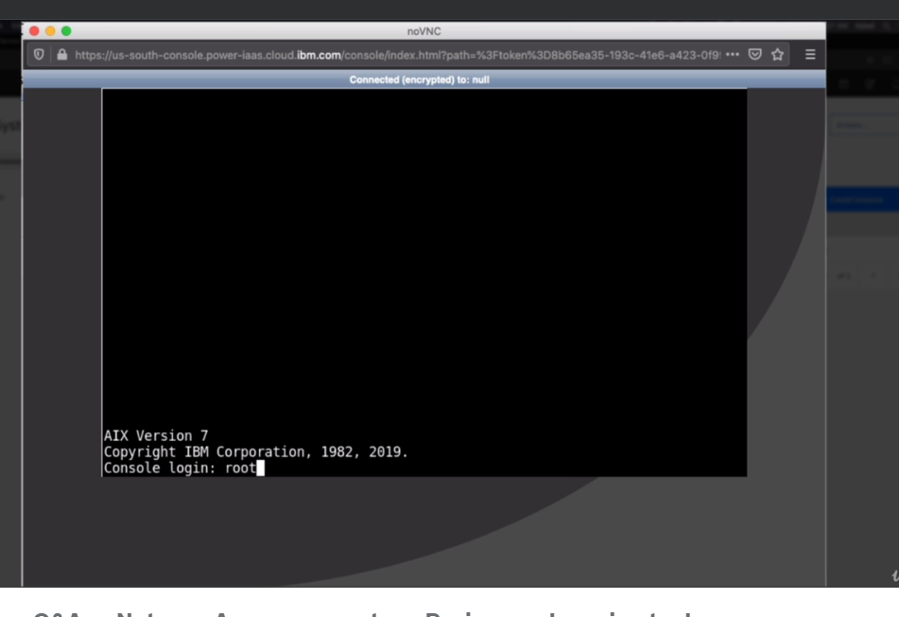

Check OS level

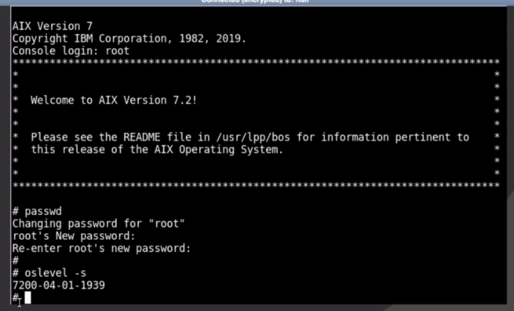

Using command oslevel -s

Access AIX systems using Putty from Windows

Download Putty

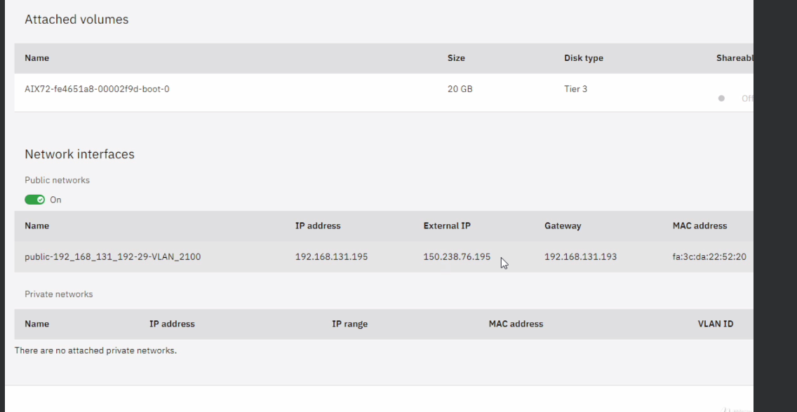

Then put the Ip select SSH and connect as root

System monitoring with TOPAS

Enter command > topas

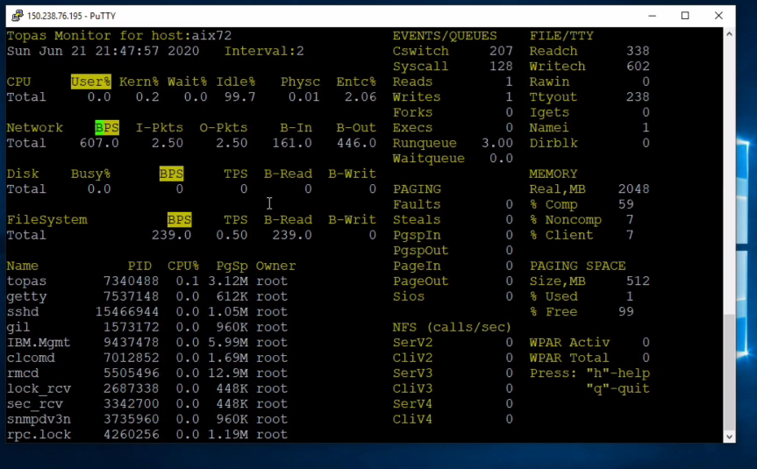

Start and stop a service in AIX

List services

lssrc -a

Start servies

startsrc -s <servicename>

stopsrc – s <servicename>

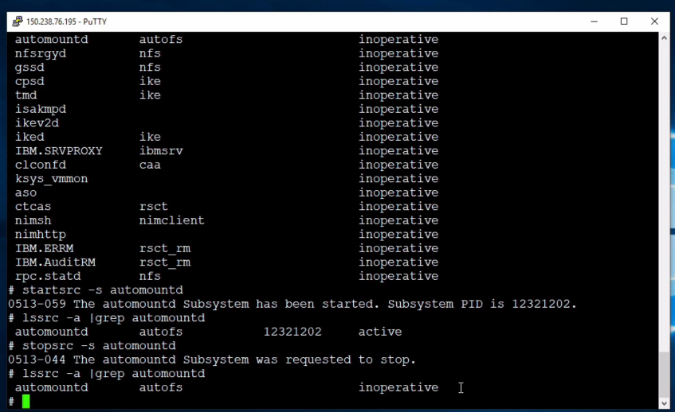

Check file system size

df command for checking disk usage

restarting AIX

command>shutdown -Fr

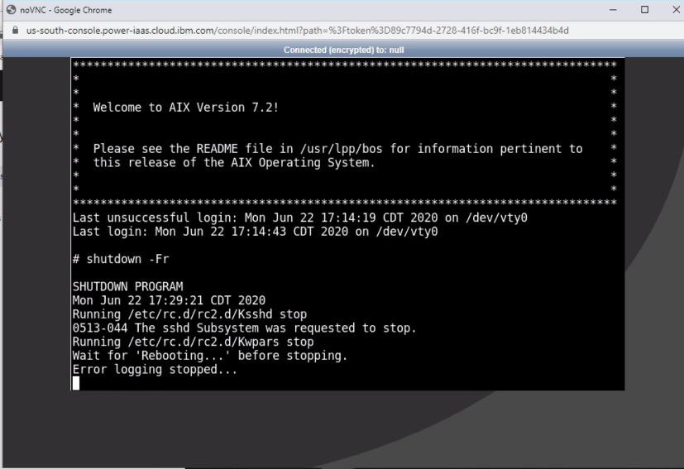

SMIT utility in AIX

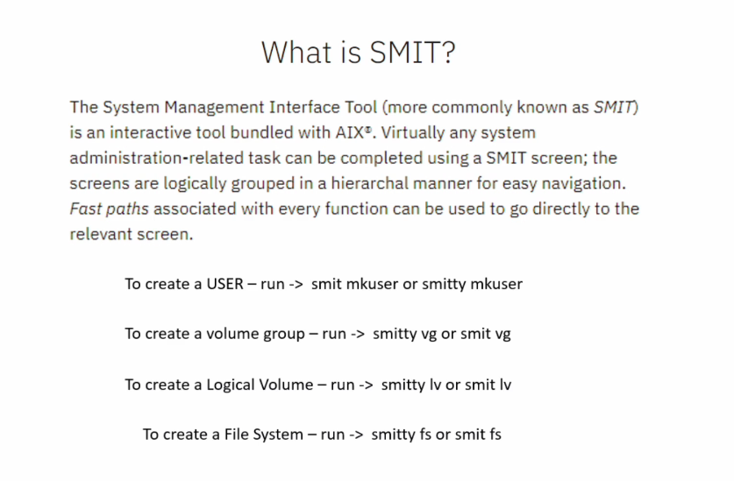

Adding a user using SMIT

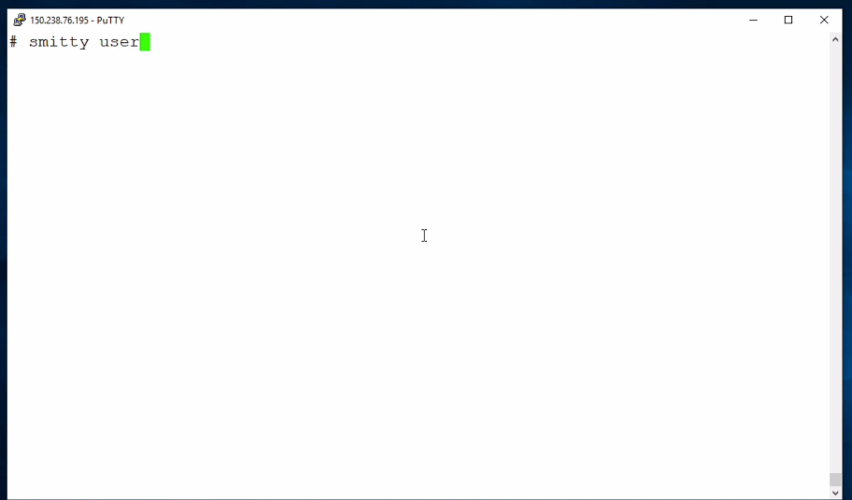

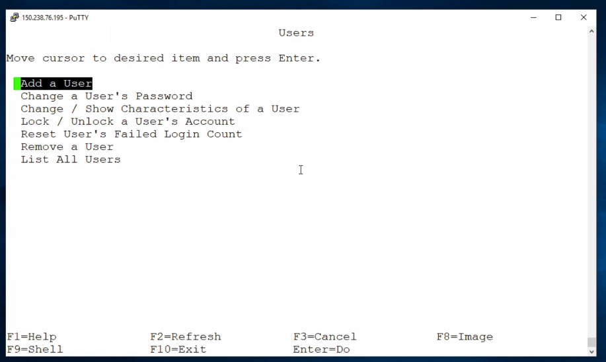

Add the user / add his name then press enter

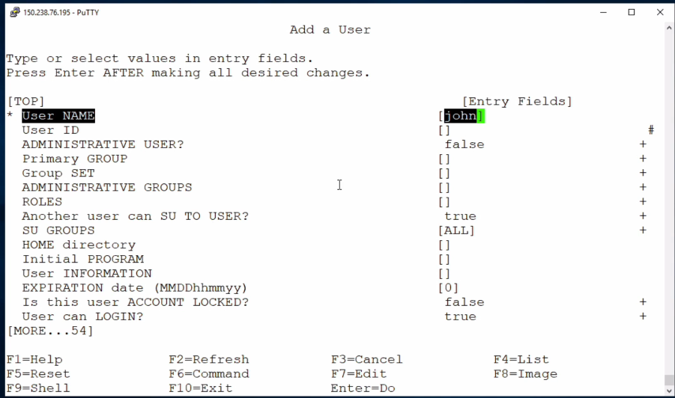

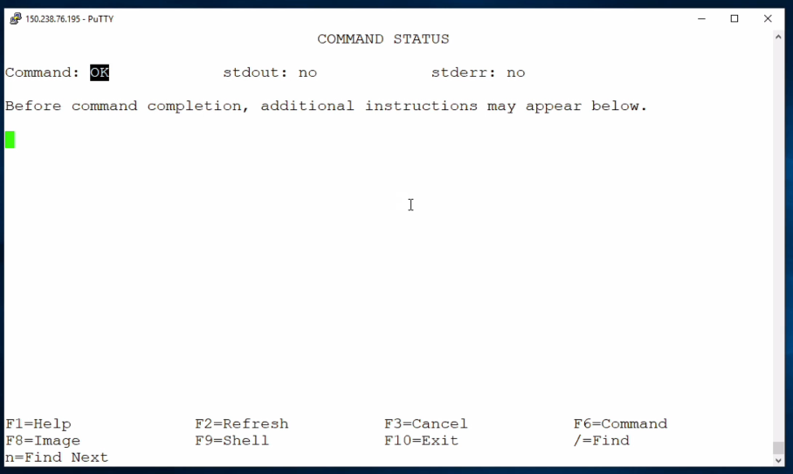

Press f10.

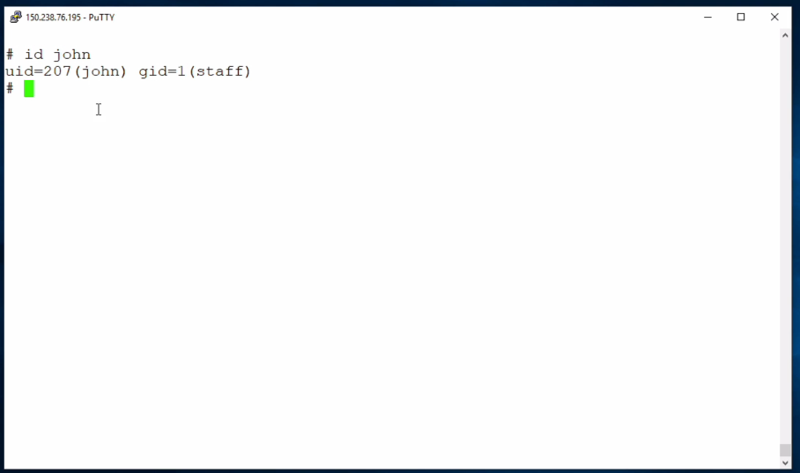

Then su <user>

Then change password

Then login to the account

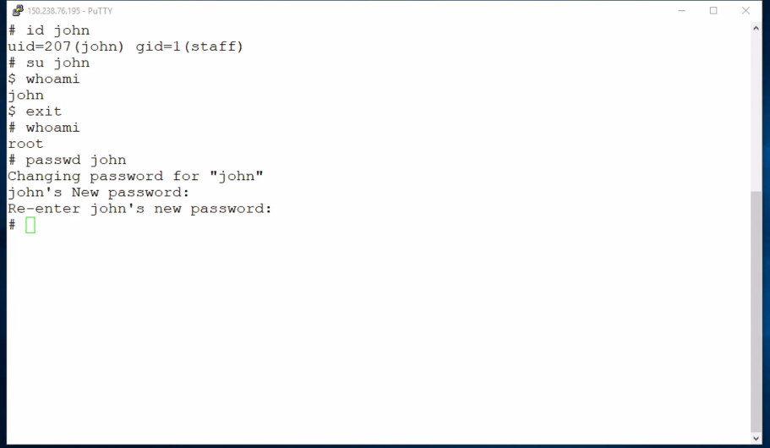

Login and change passwd

Creating group in AIX

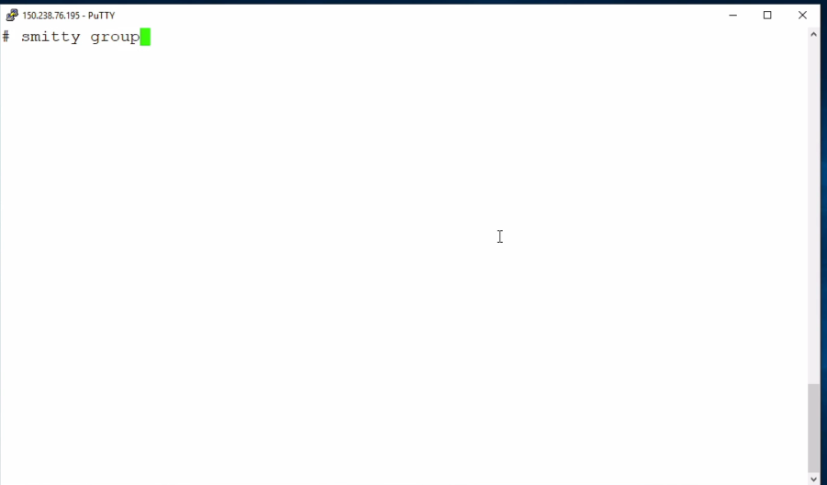

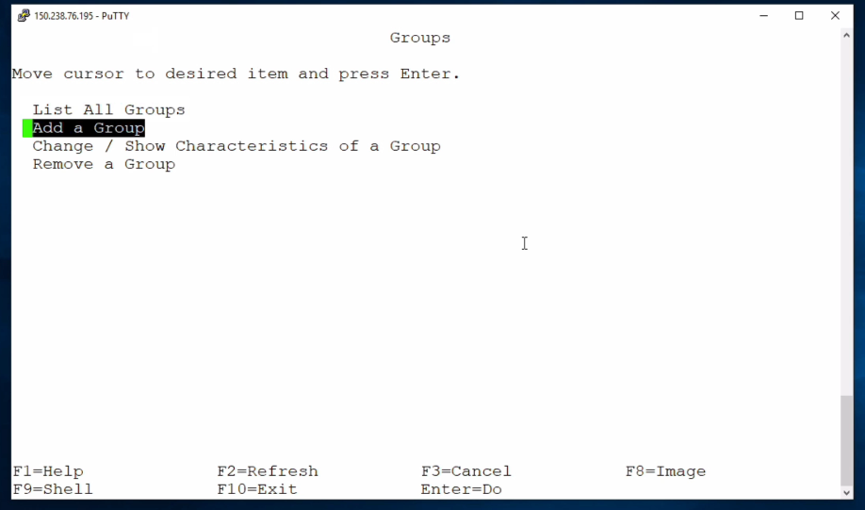

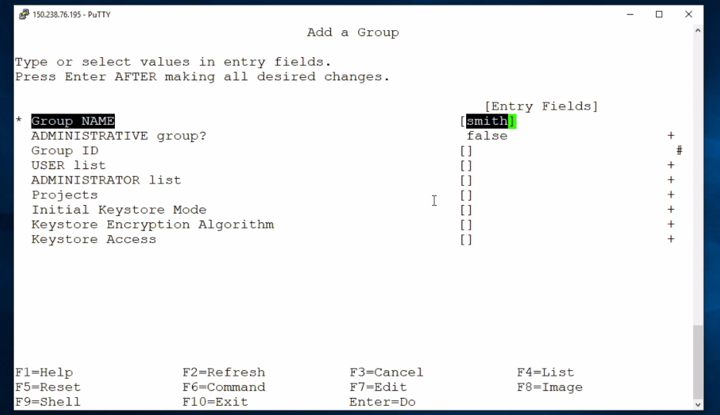

Press f10 to exit

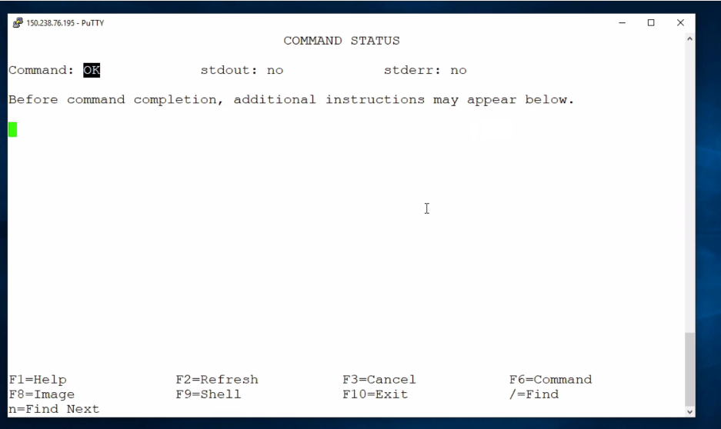

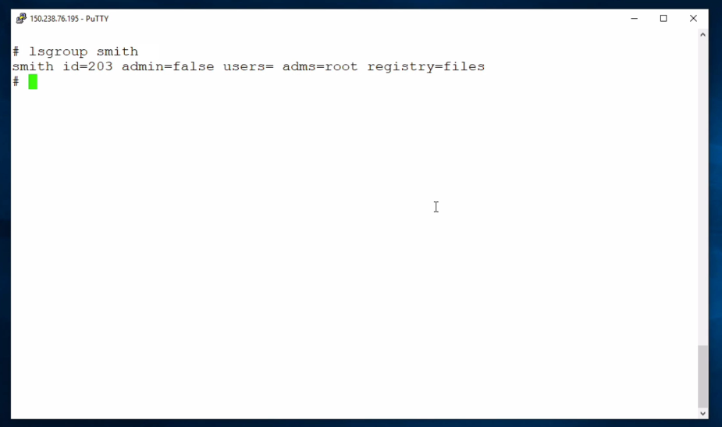

Change ownership and modify permissions in AIX

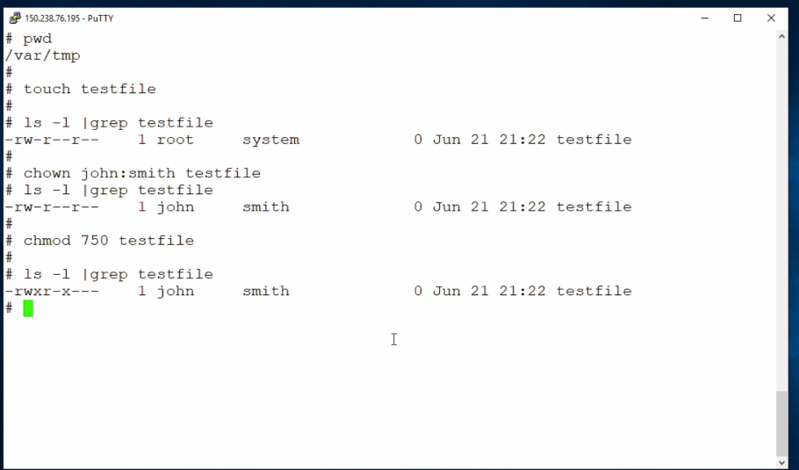

LVM In AIX

Imagine you have a bunch of Legos of different sizes and colors. You want to build a cool spaceship, but all your Legos are in separate boxes. It would be difficult to find the pieces you need and keep things organized.

LVM, or Logical Volume Manager, is like a giant storage container for your Legos (your computer's hard drive space). It takes smaller physical disks (like your Lego boxes) and combines them into larger, logical volumes (like your spaceship) that you can use more easily. Here's how it works:

* **Physical Disks:** These are your actual hard drives or Solid State Drives (SSDs). They're like the individual Lego boxes.
* **Volume Groups:** Think of these as bigger boxes where you combine multiple Lego boxes (physical disks). LVM lets you group these physical disks together to create a larger storage pool.
* **Logical Volumes:** These are the usable parts you can work with. They're like your completed spaceship built from the Legos in the bigger boxes (volume groups). You can create multiple logical volumes from a single volume group, just like you can build many spaceships from your Lego collection.

**Benefits of LVM:**

* **Easy to Resize:** Need more space for your spaceship (logical volume)? With LVM, you can easily add more Lego boxes (physical disks) to your bigger box (volume group) and grow your logical volume. You don't have to rebuild everything from scratch!
* **Improved Flexibility:** You can create multiple logical volumes from a single volume group, just like building several spaceships with different designs from your Lego collection. This allows you to allocate storage efficiently for different purposes.
* **Fault Tolerance (optional):** LVM can mirror your data across multiple physical disks. If one Lego box gets broken (disk failure), your spaceship (data) is still safe because you have a copy in another box!

**Why use LVM?**

* **Large Storage Needs:** If you need a lot of storage space, LVM lets you pool multiple disks together, making it easier to manage and use.
* **Dynamic Provisioning:** As your storage needs grow, you can easily expand your logical volumes with LVM.
* **Improved Disk Management:** LVM simplifies managing your storage by providing a logical layer on top of the physical disks.

**Analogy Recap:**

* Physical Disks = Lego Boxes
* Volume Groups = Bigger Lego Boxes (combining multiple boxes)
* Logical Volumes = Completed Spaceships (usable storage)

By using LVM, you can organize your storage space (like Legos) more efficiently, making it easier to use, grow, and manage as your needs evolve.

Add disk space from IBM cloud

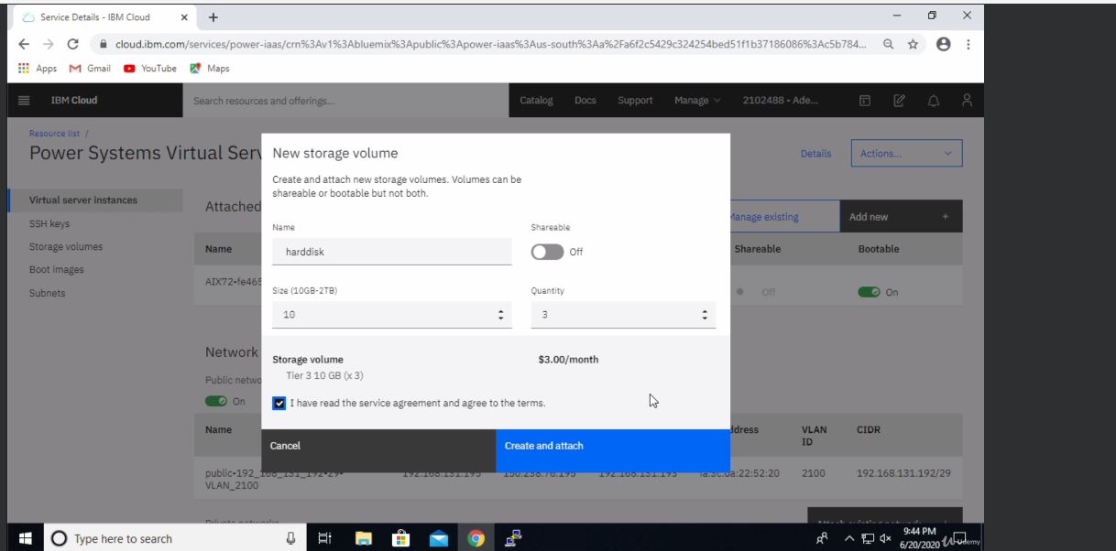

Then to scan for hardware changes use the command

>cfgmgr (it will scan the hardware for changes and reread the hardware info file)

> lspv (check for additional disk space)

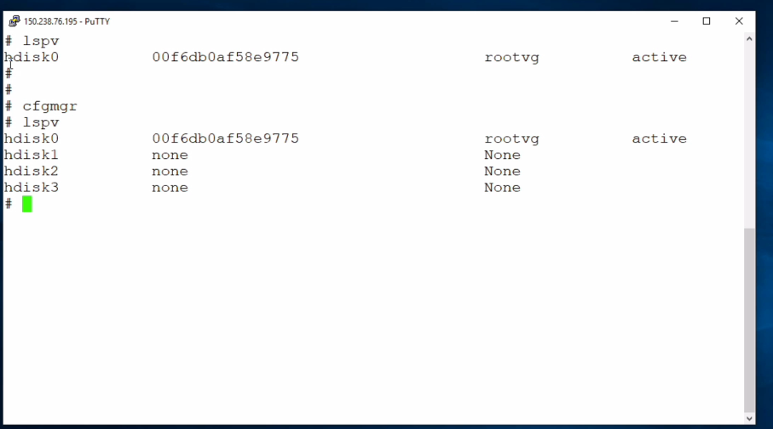

Creating a volume group using SIMT

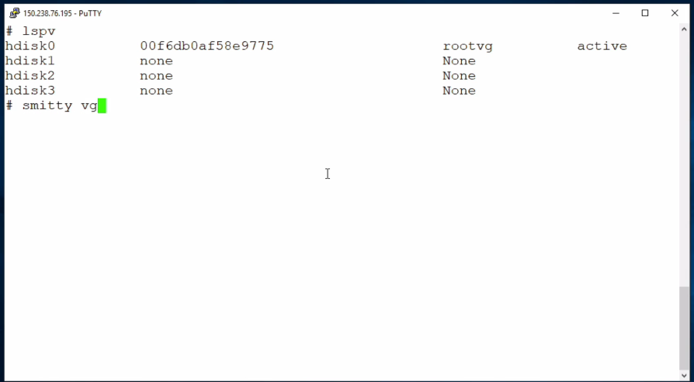

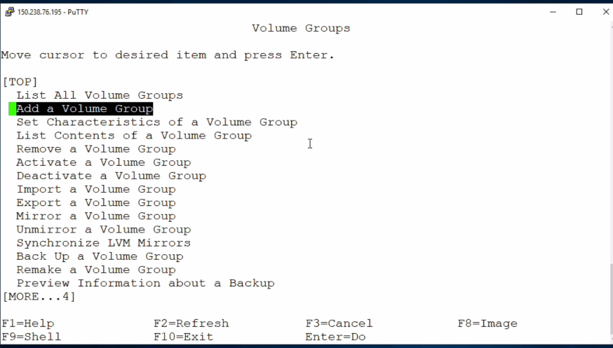

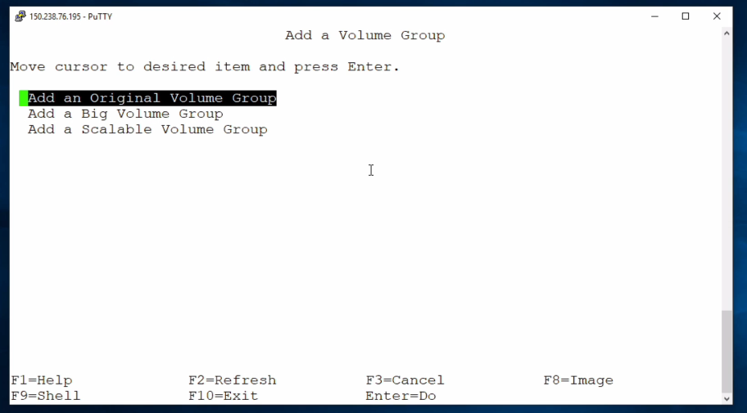

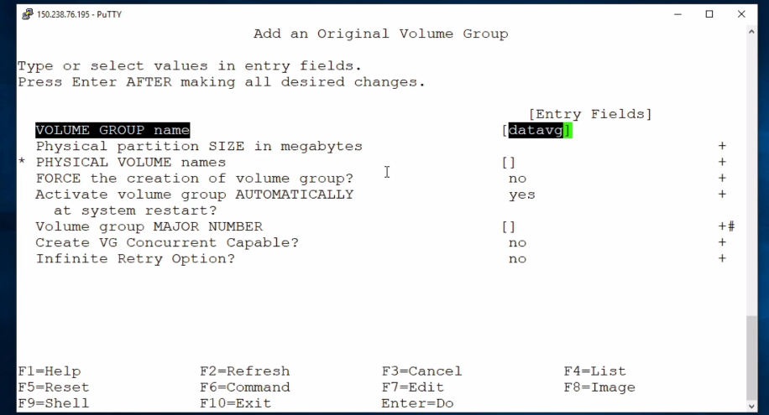

Press Escape and 4 on your keyboard .

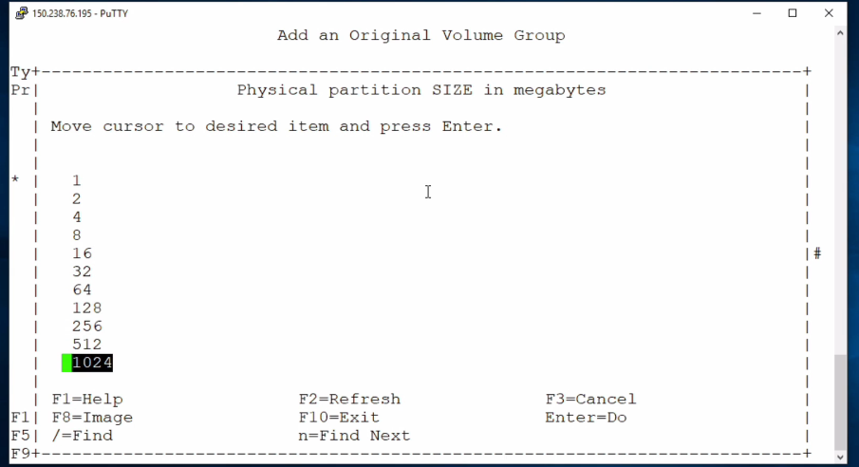

Press Escape and 4 on your keyboard .

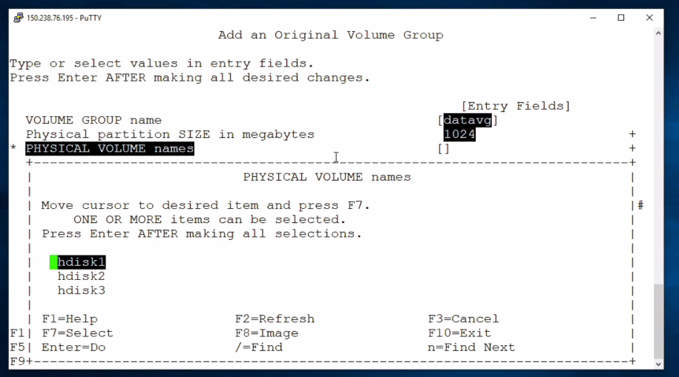

Press enter

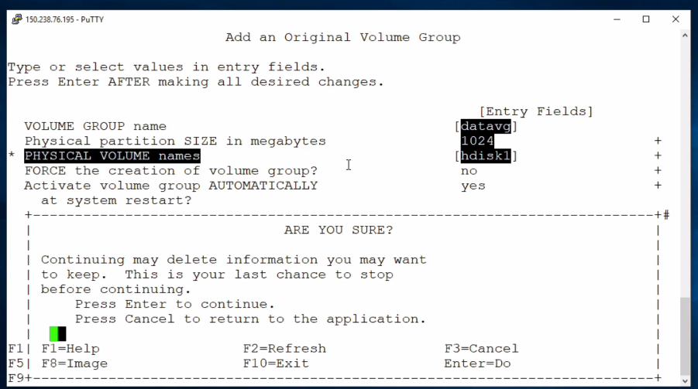

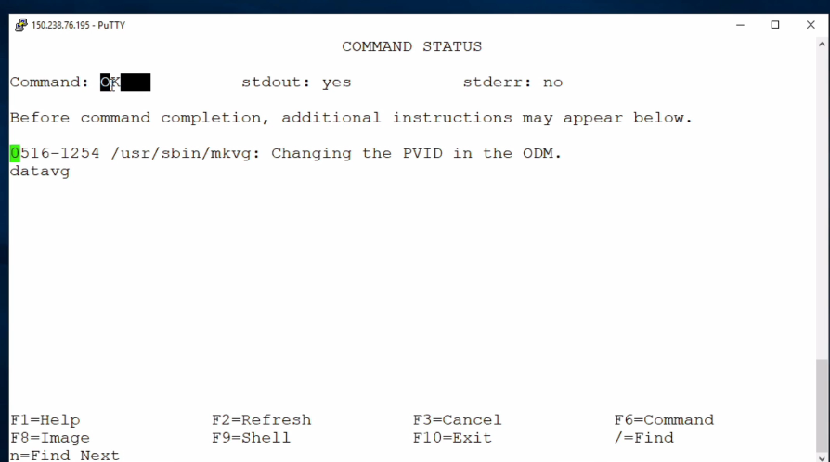

Check using the cmd lspv which shows datavg.

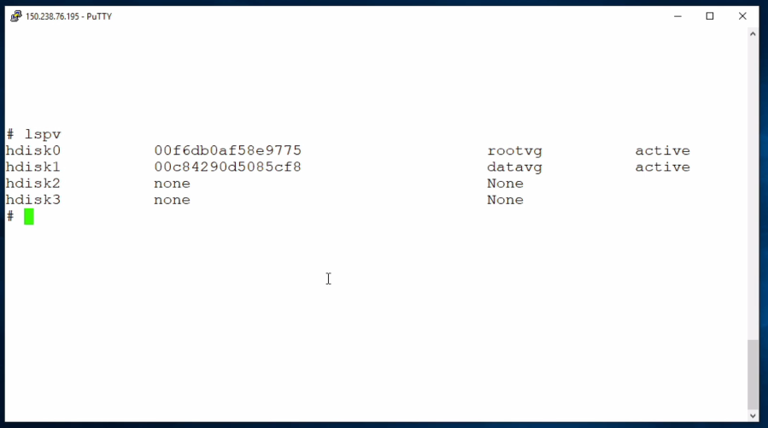

Creating logical volume

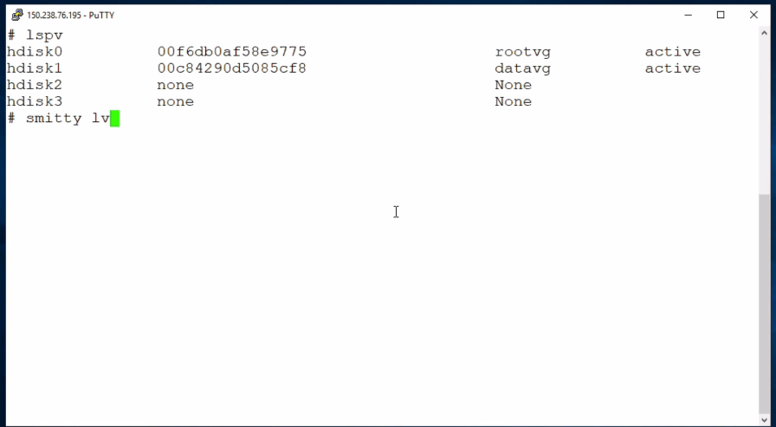

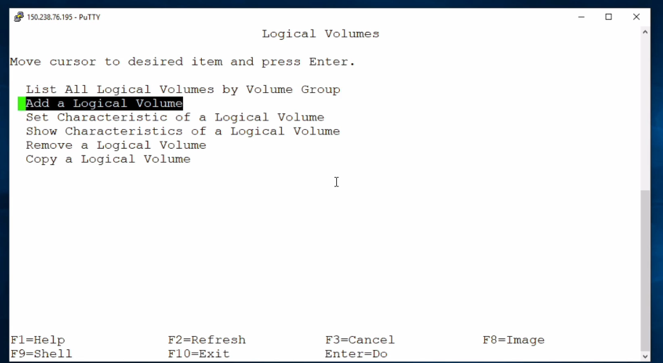

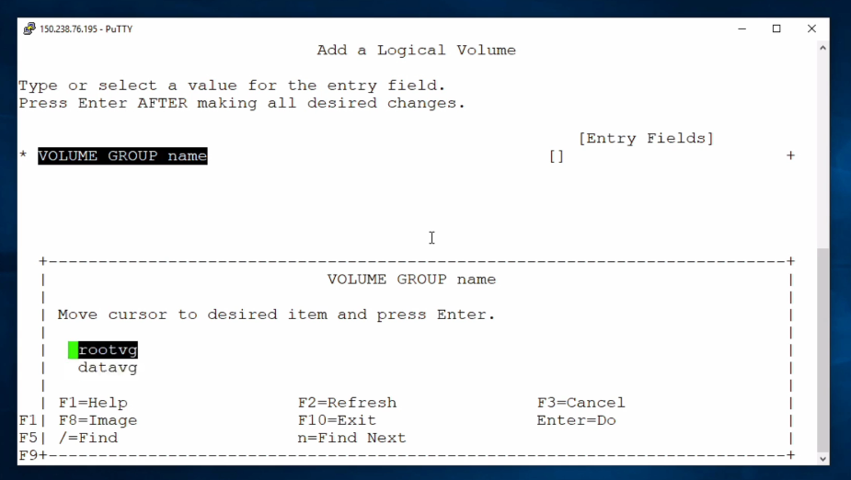

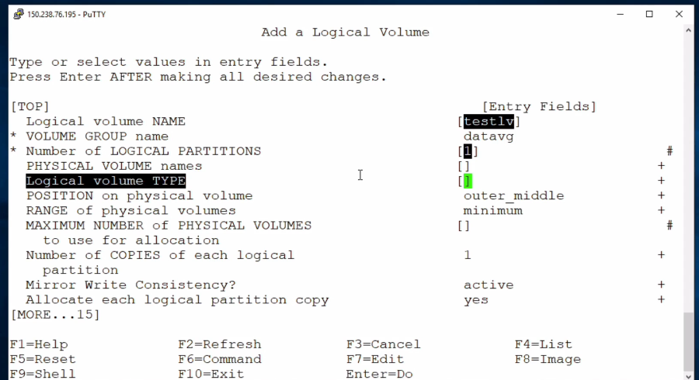

Jfs2 -> ext4

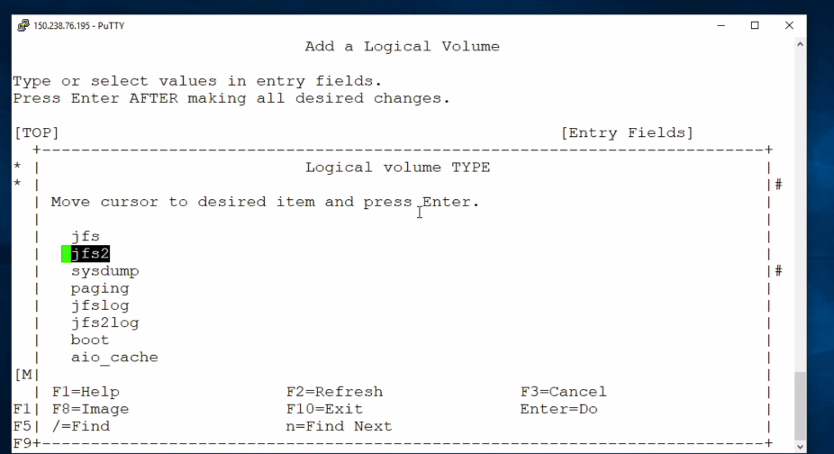

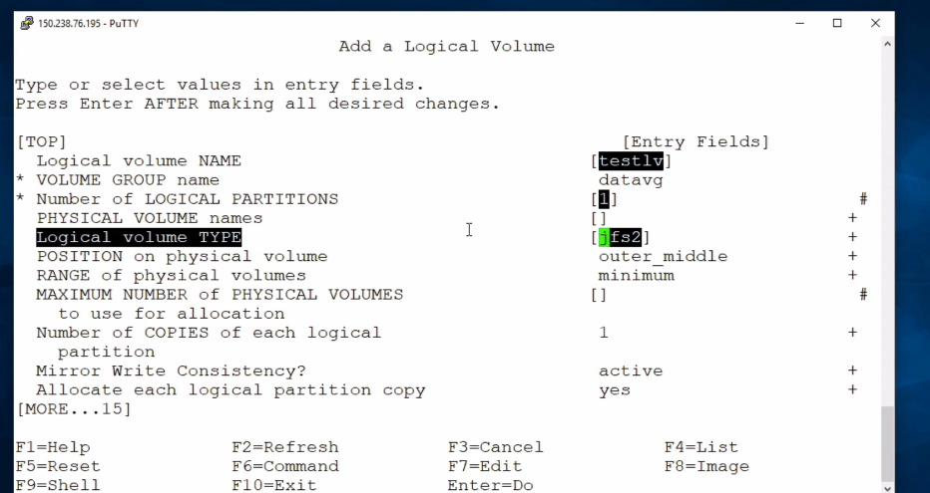

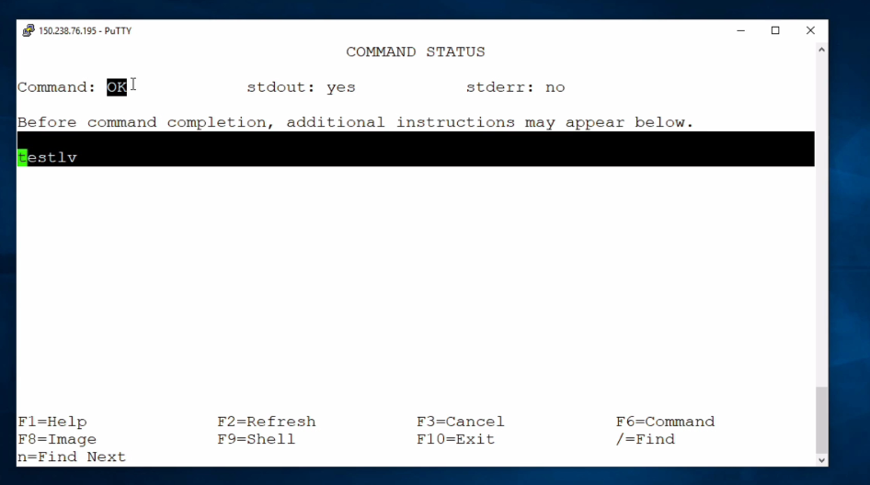

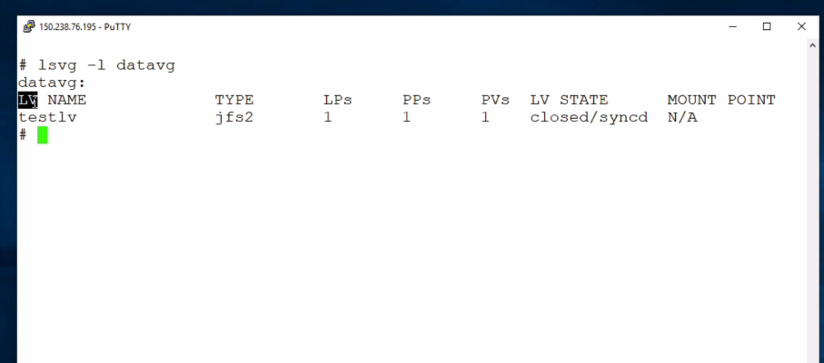

Creating a file system using SMIT



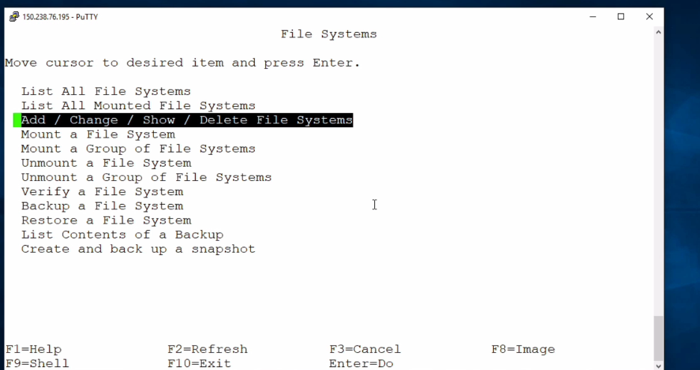

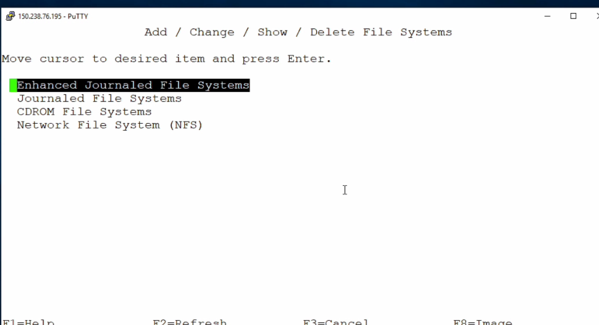

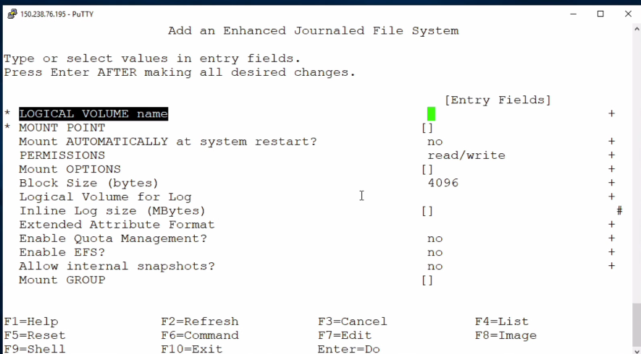

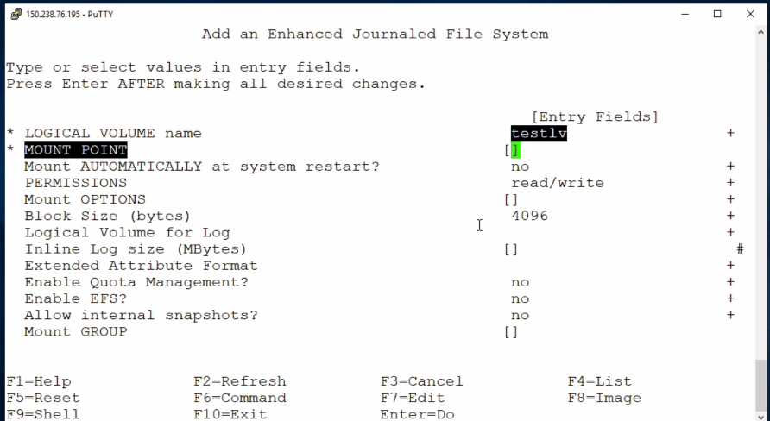

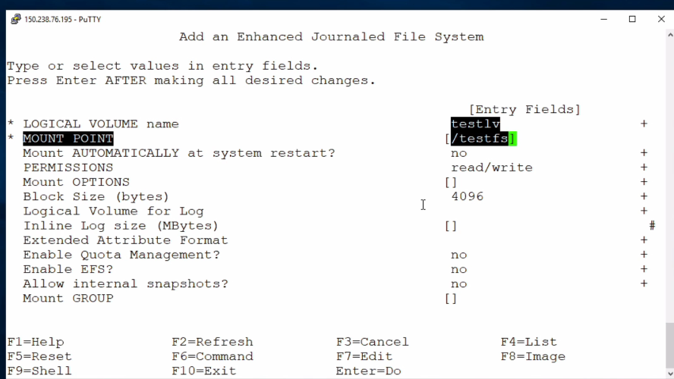

Press Escape +f4

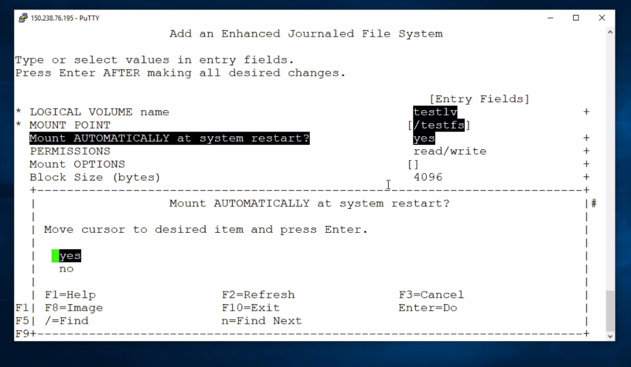

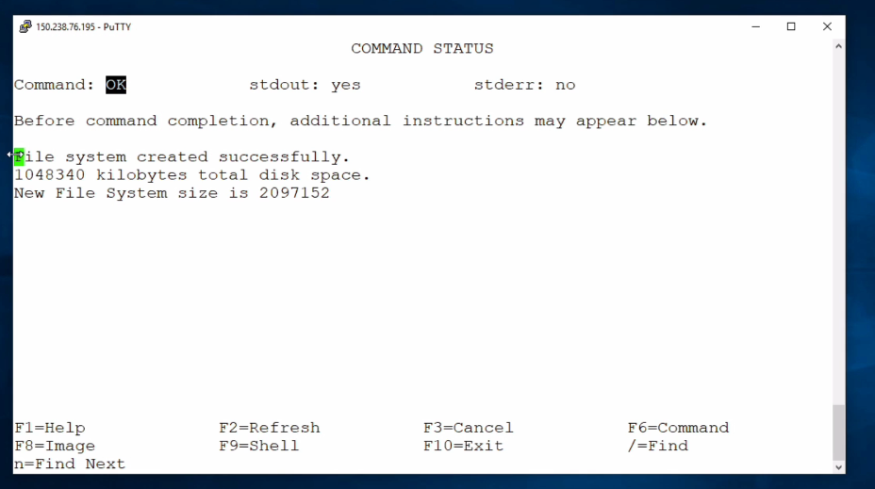

Mounting the file system

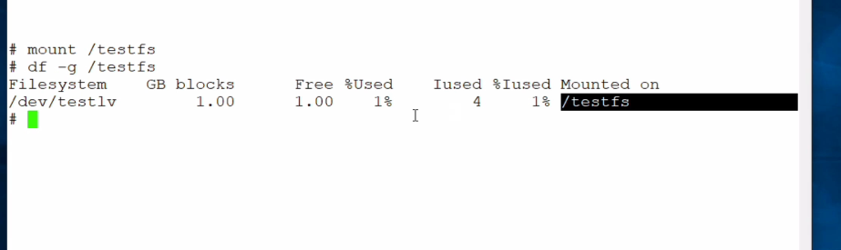

Create a volume group using just commands

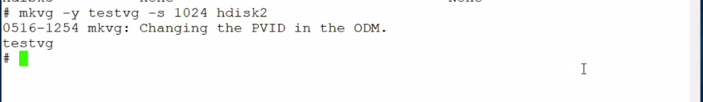

Creating logical volume

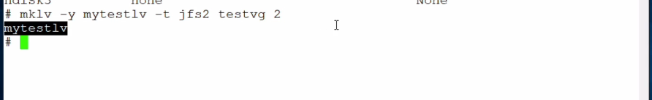

Verify volume created

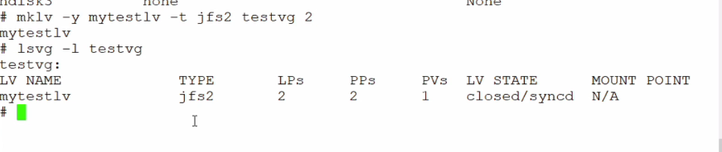

Create a file system on top of our logical volume

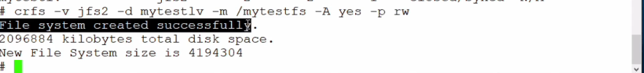

Remove LV and FS from volume group.

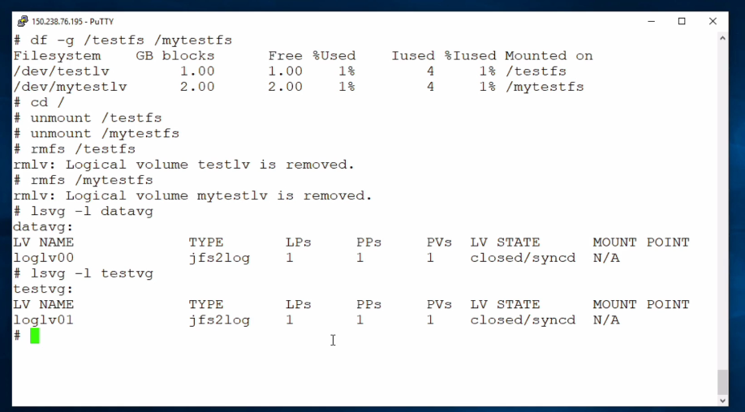

Remove volume group

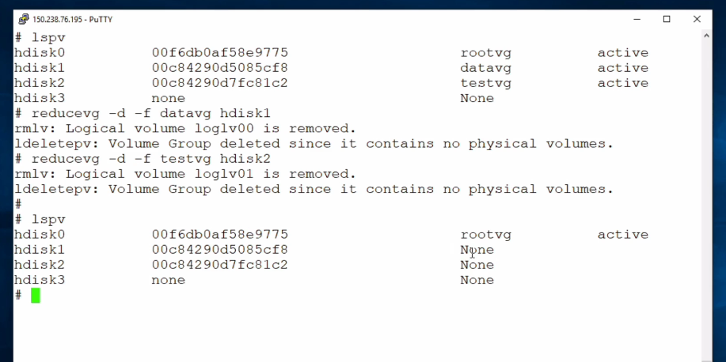

Remove Physical volumes

